

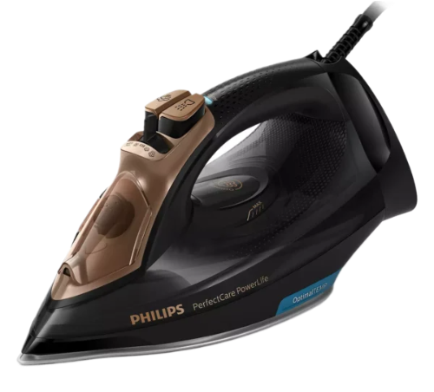

# Philips Steam Iron GC3929/60

• Quick Calc Release

• 2.5 m

• 230-240 V

• 60-70 Hz